MASTER BUSINESS ANALYSIS DOCUMENT
US Credit Card Lifecycle Analytics — Dashboard Project
Version: 1.2
Date: December 2025

1. Functional Requirements Document (FRD)
1.1 Purpose
The purpose of the Functional Requirements Document is to define the dashboard capabilities required to analyze US credit card market risk trends and visualize the lifecycle of accounts across delinquency stages. The FRD ensures a common understanding of what the system must do to meet stakeholder needs.
1.2 System Overview
The solution consists of two dashboards accessible in a web browser:
- Executive Dashboard
Shows high-level insights such as credit card balances, delinquency rate, APR distribution, YoY trends, demographic segmentation and state-level risk.
- Lifecycle Dashboard
Visualizes the movement of consumer accounts across repayment stages (Current → 30 → 60 → 90 → Default), enabling assessment of severity and collections effectiveness.
The system uses only aggregated non-PII data sourced from credible institutions and synthetic lifecycle simulation datasets.

Flowchart
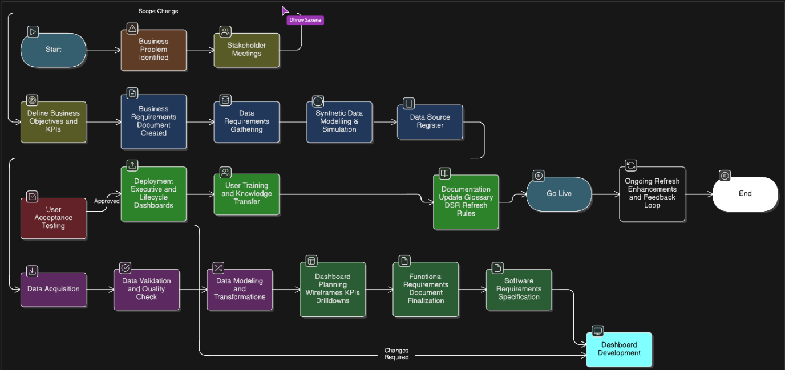

1.3 Detailed Functional Requirements
ID | Requirement | Explanation
FR-01 | Display KPI tiles | KPIs include delinquency rate, credit card balances, APR, YoY growth and household debt trends
FR-02 | Time-series trend graphs | Users can view multi-year performance to detect patterns in economic cycles
FR-03 | State-level heatmaps | Highlights high-risk regions and emerging delinquencies
FR-04 | Demographic segmentation | Supports age group, credit score band and income level filters
FR-05 | Lifecycle progression visualization | Funnel/matrix showing movement across DPD brackets
FR-06 | Cohort breakdown table | Summary of accounts transitioning between delinquency buckets
FR-07 | Drill-down to aggregated records | Clicking on charts opens table of aggregated segment data
FR-08 | Export capability | Aggregated filtered dataset can be downloaded in CSV/PDF
FR-09 | Data source attribution panel | Shows the origin, update frequency and quality rating of metrics
FR-10 | Simulation labelling | Any visual containing synthetic data must be explicitly labelled

2. Software Requirements Specification (SRS)
2.1 System Components
Component | Description
Data Layer | CSV/APIs from public sources + synthetic lifecycle datasets
ETL Layer | Scheduled ingestion + transformation for dashboard compatibility
Visualization Layer | Power BI/Tableau or web visualization platform
Metadata Layer | Source information, update regularity and quality scoring
Export Layer | Selective export of aggregated visuals
2.2 User Classes & Characteristics
User Type | Skill Level | Expected Usage
Executive Leadership | Basic | Quick portfolio monitoring
Risk/Strategy Teams | Advanced | Deep segmentation and lifecycle exploration
Collections Teams | Moderate | Understanding default pipelines
Analysts | Advanced | Drill-down & export for further modeling
2.3 Non-Functional Requirements
Category | Requirement
Usability | System must be intuitive without formal training
Accessibility | Dashboard should support tooltips and explanations for non-technical users
Performance | Default view should load under 8 seconds; heavy filtering under 12 seconds
Security | No data should be personally identifiable; no consumer-level records
Reliability | Dashboard must refresh without data integrity loss
Maintainability | Adding new KPIs or filters should require minimal rework
2.4 Assumptions & Dependencies
- All datasets are publicly available or internally approved synthetic datasets.
- No integration with production credit systems is required.
- Users will access dashboards through approved channels (URL or workspace).

3. Stakeholder Analysis
Stakeholder | Responsibility | Importance to Project
Executive Sponsor | Budget & strategic direction | Sets vision and approves outcomes
Product Owner | Requirements & prioritization | Primary decision-maker
Risk Team | Subject matter experts | Validates KPIs & lifecycle logic
BI Developers | Dashboard build & refinement | Converts requirements into visuals
Data Engineers | Data models & refresh | Ensures data reliability
Data Governance | Compliance & approvals | Ensures responsible usage
Business Users | Final consumers | Provide adoption feedback

4. RACI Matrix
Deliverable / Activity | R | A | C | I
Requirement Finalization | Product Owner | Sponsor | Risk Team | BI Team
Dataset Acquisition | Data Engineering | Product Owner | Governance | Users
Dashboard Development | BI Developer | Product Owner | Risk Team | Sponsor
Data Quality & Compliance | Governance | Governance Lead | Legal | Sponsor
User Acceptance Testing | Product Owner | Sponsor | All SMEs | Users
Launch & Enablement | Product Owner | Sponsor | BI Team | Users

5. Use Case Document
UC-01: Monitor Market KPIs
- Actor: Business User
- Description: User views latest delinquency rate, balances and APR trends
- Outcome: User identifies macro credit risk direction
UC-02: Identify Geographic Risk Concentration
- Actor: Risk Analyst
- Description: User applies state filter to compare delinquency distribution
- Outcome: High-risk states identified for targeted analysis
UC-03: Analyze Lifecycle Movement
- Actor: Risk / Collections Team
- Description: User reviews current → 30 → 60 → 90 → default conversion rates
- Outcome: Severity of delinquency pipeline is determined
UC-04: Export Segmented Dataset
- Actor: Analyst / Strategy
- Description: User exports aggregated data for further modeling
- Outcome: Dataset used for forecasting or reporting

6. User Stories
ID | User Story | Acceptance Criteria
US-01 | As a Risk Analyst, I want to compare delinquency over time | Time-series loads with accurate values
US-02 | As a Manager, I want segmentation filters to update visuals dynamically | All visuals sync instantly without reset
US-03 | As a Collections Lead, I need lifecycle visualization | Correct DPD transition counts displayed
US-04 | As an Analyst, I want drill-down and export | Export only aggregated non-PII
US-05 | As a New User, I want guidance on metrics | On-screen glossary + tooltips available

7. Data Dictionary
Field | Meaning | Type | Allowed Values
delinquency_rate | % of credit accounts 30+ days past due | Decimal | 0–100
total_balance | Total outstanding credit card debt | Currency | >0
apr | Annual interest rate | Decimal | 0–40
age_group | Customer age cohort | Text | 18–29 / 30–44 / 45–59 / 60+
credit_score_band | FICO segment | Text | Deep Subprime / Subprime / Near Prime / Prime / Super Prime
state | US state | 2-char code | AL–WY
lifecycle_stage | Delinquency progression segment | Text | Current / 30 / 60 / 90 / Default
is_simulated | Dataset simulation flag | Boolean | 0/1

8. Risk Assessment
Risk | Level | Impact | Mitigation
Incorrect usage of synthetic data for real lending decisions | High | Misleading financial insights | Clear labeling + guidance + documentation
Performance slowdown with heavy filtering | Medium | Poor user adoption | Pre-aggregated tables + query optimization
Inconsistent refresh cycles between data sources | Medium | Misinterpretation of numbers | Timestamp display for all KPIs
Export misuse / misinterpretation | Medium | Reputation risk | Export only aggregated & non-sensitive data
Low stakeholder adoption | Medium | Project under-utilized | User training + knowledge sharing sessions

